P. O. Box 164
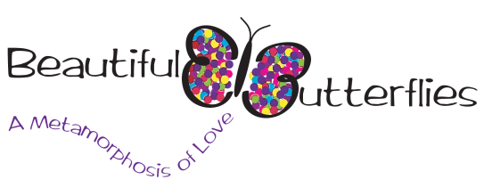
Sedalia, NC 27342

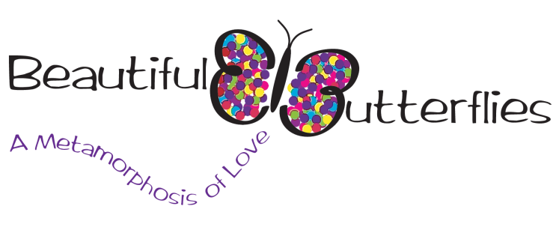
P. O. Box 164
Sedalia, NC 27342
(336) 528-4224

To Whom It May Concern:

Beautiful Butterflies Incorporated, a non-profit 501c3 lupus foundation, is tremendously excited to announce the Fourth Annual 5k Lupus Walk/Run to be held at Greenway Trail at High Point Parks and Recreation, on September 12, 2015. The walk/run is an event that will allow our mission to be pursued by supporting individuals with lupus, their families, friends and caregivers; advocating for increased public and private sector support for research on lupus, heightening awareness of the impact and affects of lupus.
The success of this event depends, in part, upon sponsorships from area businesses and organizations. Sponsors are needed to help with bottled water, snacks, fundraising prizes, and financial support. We need you to participate as a sponsor of this event by donating merchandise, gift certificates, or a financial donation. All charitable contributions will be used explicitly for needs related to the event and will be tax deductible. Furthermore, all of our sponsors will be listed, in some manner, on the event program and/or promotional materials.
Please make your financial donation by check, payable to Beautiful Butterflies Incorporated. You may mail your donation or visit us online at www.mybeautifulbutterflies.com. We thank you in advance for your participation. Your support will help Beautiful Butterflies continue its efforts to unite, inspire and strengthen people in our community and beyond.
If you have any questions or would like further information, please call or email Keva Brooks Napper at butterfliesbeautiful@yahoo.com, (336) 528-4224.

Professionally yours,

Keva Brooks Napper
Founder/Executive Director

